Breaking barriers by building bridges: the story of a 17-year-old hopeful engineer

Neeshan pushes through her challenges!

UNICEF Maldives Country Office

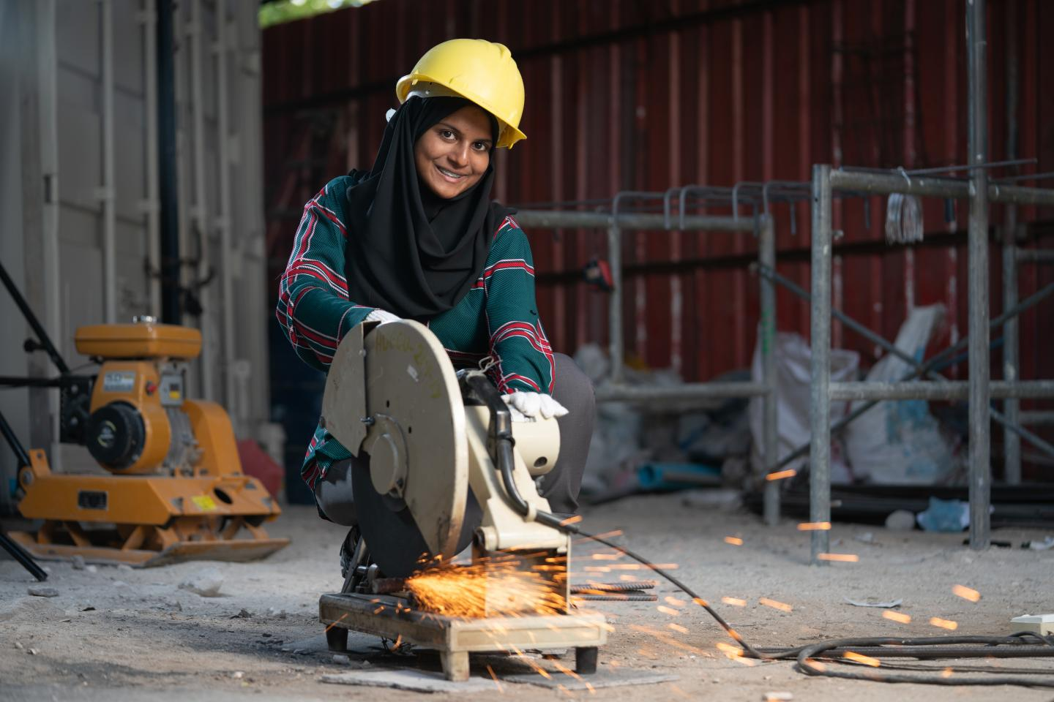
UNICEF/2018/Webster
10 October 2019
Every day, Neeshan is working to defy expectations. The 17-year-old is the only female on her construction site, but throughout her two years on the job, nothing has come close to stopping her.
“When I first began my apprenticeship, the boys would say: ‘if you can’t do something, tell me.’” Neeshan said. “By the time I finished, they would say: ‘Neeshan, can you do this for me?’ I was proud of that.”
Neeshan began her apprenticeship at age 15. Though her interests surprised her new colleagues, to her family, the job made perfect sense. Neeshan was always playing with whatever she could find as a child, assembling scraps into small structures and shapes. As she grew older, Neeshan developed a passion for math and physics. And throughout her entire childhood, she kept on the heels of her father, an electrical engineer.
“Other kids liked cartoons, but not me,” Neeshan said. “I liked to travel with my father to see what he and his colleagues were doing. Growing up, that was what I enjoyed doing.”
From an early age, Neeshan’s family was supportive of her ambition to create. At one point, when Neeshan was trying to decide what to study, Neeshan’s father guided her toward the apprenticeship programme.
“It’s all because of my family,” Neeshan said. “If they did not support me, I don’t think I would have the confidence to be here. People say things; they try to stop me. And when I chose this path, everyone told me, ‘Neeshan, this is not for you. It’s too hard. You can’t do this.’ But I gave them a deaf ear because, through all of this, my family supported me.”
“When I first began my apprenticeship, the boys would say: ‘if you can’t do something, tell me.’” Neeshan said. “By the time I finished, they would say: ‘Neeshan, can you do this for me?’ I was proud of that.”
Neeshan was one of ten apprenticeships awarded jobs at the end of the programme. This award set her apart in a country with a climbing youth unemployment rate, which is now at 17.3 per cent according to the World Bank. Neeshan decided to work for three months while continuing her studies. When she returns to school full time, Neeshan knows precisely what she wants to focus on: civil engineering.
“Through the apprenticeship, I’ve learned so many skills,” Neeshan said. “I actually got a chance to do site work and learn new things, like excavation, foundation reinforcement, machinery, plumbing, electrical skills, bar bending works, concrete, roofing and finishing. Work has been full of new experiences because you learn something new every day – for example, when the weather changes, it affects the materials we use.”
This type of work has cemented Neeshan’s aspirations to be like her father. While he was studying, Neeshan’s father ranked first in his engineering course. In the future, Neeshan plans to do the same – regardless of the fact that the female unemployment rate in the Maldives is nearly three times higher than that of men, according to the United Nations Development Programme. [EM1]
“Sometimes, knowing people think that I can’t do things is hard for me,” Neeshan said. “But either way, I’m breaking that stereotype and showing people girls can do this.”
Neeshan loves her life at the construction site, but it hasn’t come without challenges.
“So many men can’t accept girls in this field because they haven’t seen any. They believe girls can’t be successful here. I want people to understand what they are doing when they judge people. I want to change their intolerance.”
“Through the apprenticeship, I’ve learned so many skills,” Neeshan said. “I actually got a chance to do site work and learn new things, like excavation, foundation reinforcement, machinery, plumbing, electrical skills, bar bending works, concrete, roofing and finishing. Work has been full of new experiences because you learn something new every day – for example, when the weather changes, it affects the materials we use.”
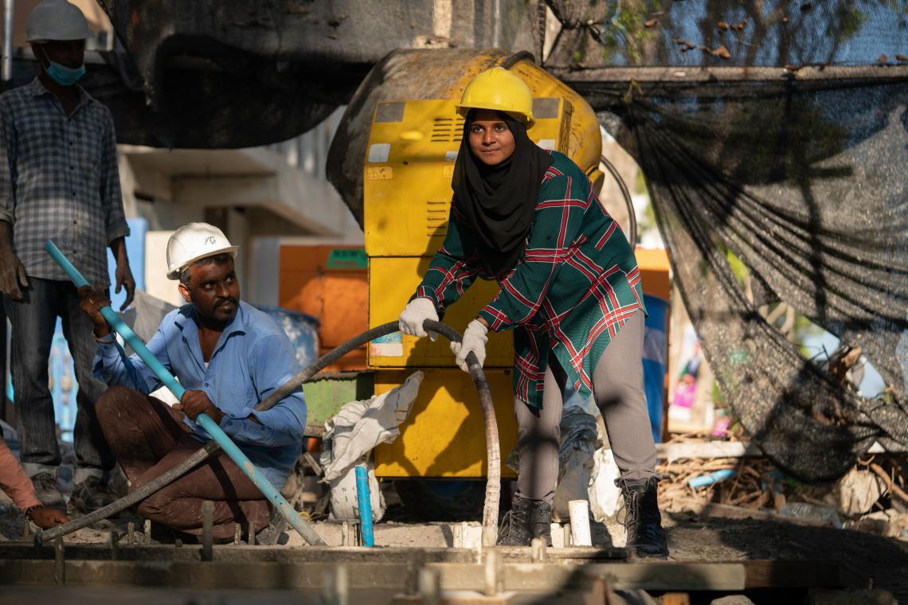
UNICEF/2018/Webster
These perceptions are grounded in the fact that, throughout the Maldives, approximately half of women are primarily engaged in home-based income-generating activities, according to the United Nations Development Programme. Often, Neeshan said, men on her construction site are bossy. They ignore her while she works, and sometimes refuse to acknowledge if she’s there or not.
At first, it was hard – but over time, Neeshan has grown used to it.
“At work, I just keep it professional,” Neeshan said. “And if I have to – if they try to be more than friends – I tell them who is boss. Every successful person has challenges, and I have challenges too. I’m ready to face and overcome them, so nothing will stop me from achieving my dreams.”
Neeshan’s grit and determination have helped her support her family, as she often gives her parents the majority of her earnings. Neeshan is proving the well-known fact that when you empower one girl, you give her the power to improve her entire community.
“My dream is to be a very good daughter, a very good sister, a very good citizen, and in the future, a very good wife,” Neeshan said. “I want to do a lot for my family and my country. I want to be someone who my family and country is proud of.”
To do so, Neeshan hopes she – and her family – can be an example of what happens when you let a child follow their dreams. She wants parents to be more supportive and tell their children not to give up when they experience hardship. She also hopes parents stop restricting their children from certain career paths, especially based on gender.
“I think that whatever you decide to do in your life, if you are committed and you do it honestly, the career itself doesn’t matter,” Neeshan said. “This is what I like to do, and because of that, I do it well. I want to be independent and a good role model for others. I’m very proud to say that I am one of those girls who didn’t listen to what other people said. Instead, I did what I wanted.”

